Evaluating Graph-Based Feedback and Iterative Backtracking in GraphEval
Experiment Report — GraphEval Prototype Research Project Author: Kyler Gundersen · Date: August 2026 Software state: branch debug/8b-hop-validation, commit b9608d0f59b5dffd30d2f51aa50cc4be745dcc93 Official experiment: apollo_multihop_llama31_8b_20260727T203028Z (2026-07-27)
Formatting note: the professor's Experiment Template-verJuly272026.docx was not available in the analysis environment; this report follows the template's specified section structure (Abstract; Introduction: Background, Objective; Methodology: Data Collection, Experiment Setup, Procedure; Results; Discussion; Conclusion; References).

Abstract
Large-language-model answers can mix supported, contradicted, and unsupported statements, and conventional final-answer scoring hides how an answer changes during self-correction. GraphEval is a prototype research instrument that decomposes a model answer into subject–relation–object CLAIM triples, evaluates each claim against trusted FACT triples extracted from context and persisted in Neo4j, labels every claim SUPPORTED, CONTRADICTED, or NO_EVIDENCE, feeds the labels back for revision, and validates a trusted evidence path before declaring an answer resolved. This report describes the completed official experiment: a 50-question Apollo-domain multihop benchmark (five questions at each designed graph-path depth 1–10) run with llama3.1:8b via Ollama (temperature 0, 8192-token context, at most three iterations per sub-question) at frozen commit b9608d0. All 50 questions completed with no runtime errors or timeouts. 27/50 final answers matched the expected answer exactly (54%), 43/50 contained it (86%), and the pipeline resolved 33/50 (66%) with a complete trusted evidence path in 36/50. The dominant divergence was textually-correct-but- pipeline-unresolved (15/50). All 27 questions resolved on the first pass were answered correctly or near-correctly, while only 6 of the 23 questions that entered revision ever resolved. Trace-level case studies show both successful feedback-driven correction (a depth-8 question revised twice into an exactly correct, fully path-validated answer) and a pipeline-mediated regression (a WannaCry depth-10 question whose initially correct bulletin identifier, MS17-010, was lost through malformed decomposition, projection, and unsuccessful revision). The main limitations are the small per-depth sample (five questions), a single model and domain for the quantitative sample, LLM nondeterminism, and the absence of a controlled no-feedback baseline, which precludes causal claims about correction efficacy.

1. Introduction

1.1 Background
An LLM answer to a multi-step factual question is typically scored only on its final text. That practice hides several distinct behaviors: an answer can be textually correct while resting on unverifiable reasoning; it can contain a correct entity embedded in unsupported elaboration; and iterative self-correction can silently remove correct information as easily as it removes errors. Understanding these behaviors requires a representation in which individual statements can be inspected, rejected, preserved, or replaced.
The broader motivation of this project is structured memory and correction: how an AI system represents the information in its answers, what it preserves during correction, what it forgets or removes, and how incorrect information persists. The GraphEval prototype studied here is not a complete conversational-memory system; it is an experimental instrument for observing answer decomposition, claim evaluation, preservation, revision, and failure at the level of individual triples.
The instrument keeps two concepts strictly separate. A FACT is a subject–relation–object triple extracted from trusted context, treated as trusted evidence, stored as a FACT relationship in Neo4j, and usable in evidence-path validation. A CLAIM is a triple extracted from a model answer; it is evaluated against trusted FACTs and labeled SUPPORTED, CONTRADICTED, or NO_EVIDENCE, and it remains a CLAIM even when supported — the pipeline never promotes a supported claim into a FACT. A triple is Subject — Relation → Object; for example, Microsoft Security Bulletin MS17-010 — supplied_correction_to_vulnerability → how SMBv1 handled crafted requests.
The prototype follows the GraphEval idea of verifying LLM output as a knowledge graph rather than as free text. [TODO: verify and cite the original GraphEval publication; the repository does not record the source, and no attribution is invented here.]

1.2 Objective
The experiment is descriptive. Its research questions are:
- RQ1. How reliably does GraphEval produce textually correct and graph-resolved answers across designed graph-path depths 1 through 10?
- RQ2. During iterative revision, how does GraphEval handle claims labeled SUPPORTED, CONTRADICTED, and NO_EVIDENCE?
- RQ3. Which observed failures originate primarily in the LLM, which originate in the GraphEval pipeline, and which are mixed failures involving both?
- RQ4. What does the trace reveal about preservation, correction, removal, or regression of answer information between the initial and final response?
The main objective is therefore to evaluate final textual correctness, graph-grounded resolution, behavior across depth, claim-label feedback, preservation and regression during revision, and observable model and pipeline failure modes. Because the experiment contains no controlled no-feedback or text-only-feedback baseline, no causal claim is made that graph feedback outperforms ordinary self-correction.

2. Methodology

2.1 Data Collection
Primary quantitative dataset. The Apollo 50-question multihop benchmark (data/test_sets/apollo_multihop_50.json) contains 50 questions over a fixed designed knowledge graph of Apollo/NASA public history: 42 nodes, 48 edges, one connected component, rooted at Apollo 11, with exactly five questions at each designed depth 1–10 (validator-confirmed inside the result file). Designed hop depth means root-to-answer graph-path depth in this fixed graph; it does not force a number of visible reasoning statements, does not equal the number of LLM calls, and is separate from question decomposition. Each question carries trusted context (the text from which FACTs are extracted) and an expected answer and expected path used only for post-inference scoring; a dedicated test (tests/test_expected_answer_leakage.py) enforces that expected answers are never supplied to inference.
Qualitative case data. One preserved execution of a WannaCry-domain depth-10 question (nhs_wannacry_h10_q01, benchmark nhs_wannacry_multihop_50, grounded in NAO, DHSC, CISA, and Microsoft sources) is analyzed as a separate qualitative case; it is never pooled with the Apollo sample. Representative cases were selected from existing artifacts to cover first-pass success, successful revision, honest rejection, conservative stalls, regression, and high-depth success and failure; no new model outputs were generated and no unfavorable rows were rerun.
No human participants were involved.

2.2 Experiment Setup
All values below were verified from the result JSON, the preserved runner log/rc files, and preserved shell history (exact command in research/EXPERIMENT_EVIDENCE_INVENTORY.md).
Item | Value
Frozen commit | b9608d0f59b5dffd30d2f51aa50cc4be745dcc93 (branch debug/8b-hop-validation)
Model / provider | llama3.1:8b via Ollama (all seven LLM stages)
Context window | num_ctx 8192; max observed prompt ≈ 1670 tokens (limit never approached)
Sampling | temperature 0; num_predict 4096
Iteration limit | 3 per sub-question
Timeout | 180 s per question
Graph store | Neo4j 5.26.0 (Docker), required, cleared between questions, execution-scoped; claim evaluation via Neo4j readback in all 50 rows
Runner | scripts/run_multihop_benchmark.py (--continue-on-error, cooldown 2 s)
Outputs | results/research/apollo_multihop_llama31_8b_20260727T203028Z.{json,md}
Host | local WSL2/Ubuntu workstation running Ollama; detailed hardware was not recorded in run artifacts and is not claimed

Component responsibilities. The LLM performs answer generation, question decomposition, context FACT extraction, sub-answer projection, CLAIM extraction, and answer revision. Deterministic Python performs decomposition validation, structured-triple validation, schema-alignment safety checks, claim comparison and label assignment, target derivation and validation, trusted evidence-path resolution, stop-condition logic, benchmark scoring, and trace/metric construction. Neo4j persists FACTs and CLAIMs scoped by execution ID and supports graph queries and traceability; it does not generate answers, never receives the expected answer, and never promotes CLAIMs to FACTs.
Instrument validation before the experiment. The offline test suite passed at the frozen commit (PR #5 reported 406 passed / 16 skipped, with focused reliability tests 26 passed and related pipeline tests 93 passed / 1 skipped; re-verified in this analysis pass with 430 passed, 16 skipped — the additional 24 tests come from an untracked behavior-suite test file added after the freeze). Live Apollo depth-1/2/3/10 acceptance runs succeeded after the reliability correction (.runtime/benchmarks/apollo_depth_acceptance*), and Neo4j execution isolation and FACT/CLAIM separation are covered by dedicated tests.

2.3 Procedure
For each benchmark question the pipeline executes:
- load the question and trusted context;
- optionally decompose the question into sub-questions (LLM, then deterministic validation);
- extract FACT triples from context, validate them (rejecting anomalies such as empty objects), write them to Neo4j, and read back the working graph;
- generate the initial answer (LLM);
- project the compound answer onto each sub-question (LLM);
- extract CLAIM triples from each sub-answer (LLM);
- apply safe schema alignment of claim fields to canonical graph vocabulary (deterministically bounded);
- compare CLAIMs to FACTs;
- assign SUPPORTED / CONTRADICTED / NO_EVIDENCE labels;
- build structured feedback from the labels;
- revise the answer (LLM);
- validate the derived question target;
- validate the trusted evidence path from the question's start entity to the terminal claim;
- stop (RESOLVED, STALLED, or UNRESOLVED_*) or iterate up to the limit;
- combine sub-answers into the final answer;
- score the final answer textually against the expected answer (post-inference only);
- save the per-question row, metrics, and (when enabled) a JSONL debug trace.
Analysis. Quantitative results were produced by scripts/analyze_final_experiment.py, which recomputes every aggregate from the 50 raw rows and hard-fails if any value disagrees with the runner's own summary block (all values agreed). Figures were generated from the analysis JSON by scripts/plot_final_experiment.py. Qualitative analysis inspected preserved JSONL debug traces event-by-event; the full case records are in research/REPRESENTATIVE_TRACE_CASES.md.

3. Results

3.1 Overall results
All 50 questions completed; 0 errors, 0 timeouts, 0 resumed checkpoints. Total 83 sub-question iterations and 33 revisions. Runtime per question: min 37.5 s, Q1 40.9 s, median 44.9 s, Q3 52.8 s, max 72.5 s, mean 48.4 s.
Metric (n = 50) | Count | Rate | Wilson 95% CI
Exact match | 27 | 0.54 | [0.40, 0.67]
Contains expected | 43 | 0.86 | [0.74, 0.93]
Normalized match | 43 | 0.86 | [0.74, 0.93]
Pipeline resolved | 33 | 0.66 | [0.52, 0.78]
Complete trusted evidence path | 36 | 0.72 | [0.58, 0.83]

These five measures are distinct: exact match and contains-expected are textual post-hoc scores; pipeline resolution is the deterministic verdict; path completeness and target satisfaction are its two main components. They must not be conflated — contains-expected in particular does not mean the final answer was ideal.

3.2 Stop reasons
Final stop reason | Count
RESOLVED | 33
STALLED | 7
UNRESOLVED_TARGET_NOT_SATISFIED | 7
UNRESOLVED_NO_EVIDENCE | 3

(Target satisfaction is observable through the UNRESOLVED_TARGET_NOT_SATISFIED stop reason; rows do not carry a separate boolean.)

3.3 Joint textual correctness × pipeline resolution
Joint outcome | Contains-expected basis | Exact-match basis
Textually correct and pipeline resolved | 28 | 27
Textually correct but pipeline unresolved | 15 | 0
Textually incorrect but pipeline resolved | 5 | 6
Textually incorrect and pipeline unresolved | 2 | 17

The dominant divergence is textually-correct-but-unresolved (15/50): the model's text contained the expected entity, but the pipeline could not assemble a supported, target-satisfying, path-complete structured account of it. The reverse divergence (resolved but textually wrong, 5/50) shows honest graph resolution landing on the wrong semantic target (e.g. case apollo_hop_037, final answer "state"). The runner's resolved_and_matched_count of 28 uses its permissive answer_match flag; the strict exact-and-resolved count is 27.

3.4 Results by designed depth
Five questions per depth: counts below are descriptive and do not establish statistical depth trends.
Depth | Exact | Contains | Resolved | Path complete | Avg iterations | Avg revisions | Mean runtime (s)
1 | 4/5 | 5/5 | 4/5 | 4/5 | 1.2 | 0.2 | 40.7
2 | 3/5 | 5/5 | 3/5 | 4/5 | 1.6 | 0.6 | 46.9
3 | 3/5 | 3/5 | 4/5 | 4/5 | 1.4 | 0.4 | 43.4
4 | 2/5 | 4/5 | 2/5 | 4/5 | 1.8 | 0.8 | 52.0
5 | 4/5 | 4/5 | 5/5 | 5/5 | 1.4 | 0.4 | 47.7
6 | 4/5 | 5/5 | 4/5 | 4/5 | 1.4 | 0.4 | 46.8
7 | 1/5 | 4/5 | 2/5 | 2/5 | 1.8 | 0.8 | 48.1
8 | 1/5 | 4/5 | 3/5 | 3/5 | 2.2 | 1.2 | 53.9
9 | 3/5 | 4/5 | 4/5 | 4/5 | 2.0 | 1.0 | 52.0
10 | 2/5 | 5/5 | 2/5 | 2/5 | 1.8 | 0.8 | 52.6

Descriptively, exact match and resolution are high at depths 1–6 (except depth 4), weaker at depths 7, 8, and 10, and contains-expected stays high at every depth (3/5 at depth 3 is its only dip). Iterations and runtime drift upward with depth. Depth-10 questions were resolvable: two resolved with complete nine-edge trusted paths, including apollo_hop_046 exactly ("Oceanography").

3.5 Revision behavior
Group | Count | Exact | Contains | Resolved
First-pass (0 revisions) | 27 | 24 | 25 | 27
Revised (≥ 1 revision) | 23 | 3 | 18 | 6

Resolution ends iteration, so first-pass rows are resolved by construction; the table's information is that 24 of 27 first-pass resolutions were also exactly correct. Of the 23 questions that entered revision, 6 eventually resolved, 17 ended unresolved, and 5 still did not contain the expected answer. The official-run rows do not store initial answers or per-iteration labels (debug_log_path is null), so full initial-to-final transition matrices are computable only for the separately traced qualitative cases; this is a documented instrument limitation, not an analysis choice.

3.6 Final claim labels
Label | Total claims (final iterations) | Questions containing label
SUPPORTED | 65 | 44
CONTRADICTED | 1 | 1
NO_EVIDENCE | 12 | 10

At the final iteration the Apollo run was dominated by SUPPORTED claims; CONTRADICTED was rare (one claim in one question). NO_EVIDENCE, present in 10 questions, is the label most associated with non-resolution. Label transitions across iterations are not recoverable for the official run (see 3.5); the WannaCry trace below provides a fully observed example (initial SUPPORTED MS17-010 claims, final 2 SUPPORTED / 4 CONTRADICTED / 1 NO_EVIDENCE).

3.7 Figures
- Figure 1 — results/research/figures/fig1_outcomes_by_depth.png: exact / contains / resolved counts by depth (five questions per depth; raw counts, no trend lines).
- Figure 2 — fig2_joint_outcomes.png: joint textual × pipeline outcomes.
- Figure 3 — fig3_stop_reasons.png: stop-reason distribution.
- Figure 4 — fig4_revision_outcomes.png: first-pass vs revised outcomes.
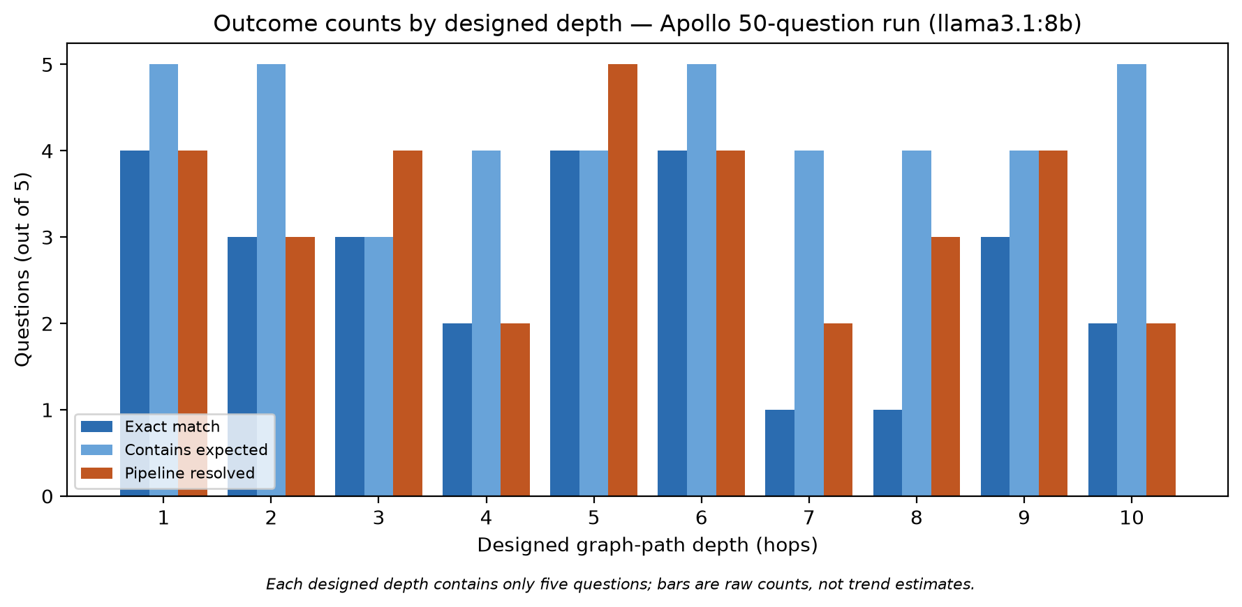
Figure 1. Outcome counts by designed depth. Each depth contains only five questions; bars are raw counts, not trend estimates.
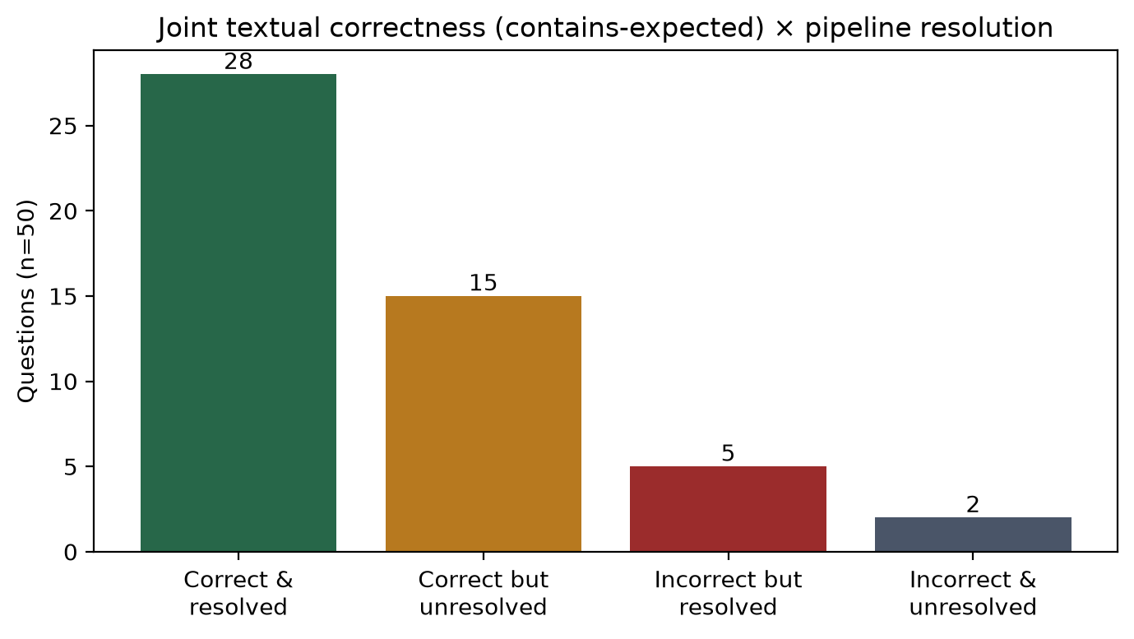
Figure 2. Joint textual-correctness (contains-expected) × pipeline-resolution outcomes (n=50).
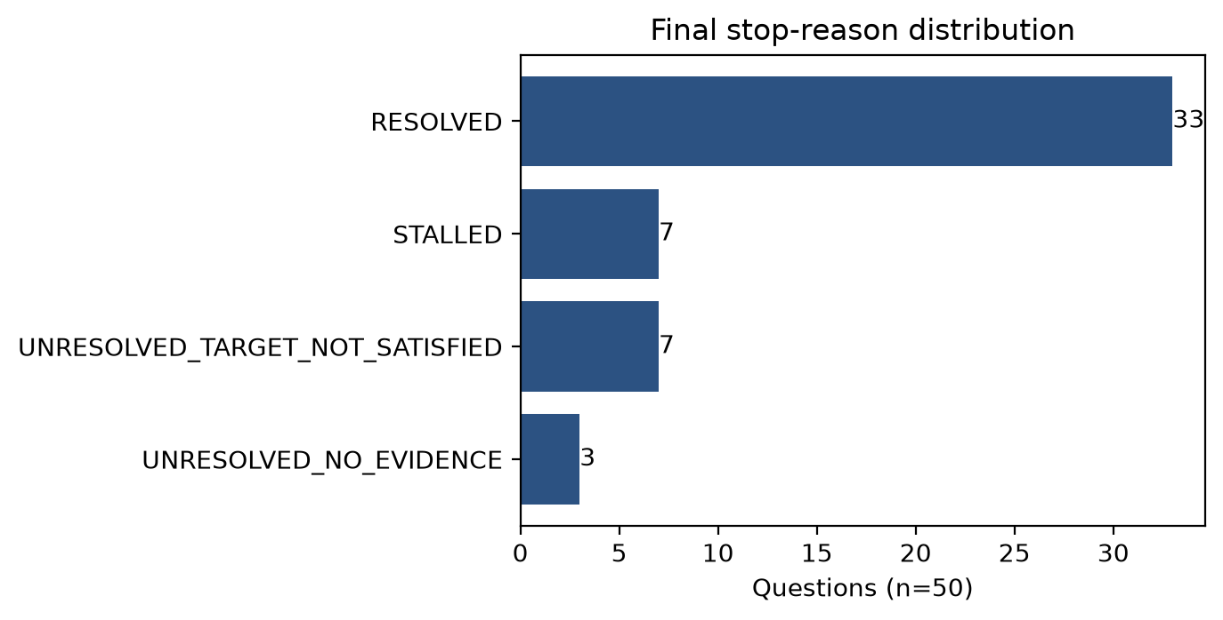
Figure 3. Final stop-reason distribution (n=50).
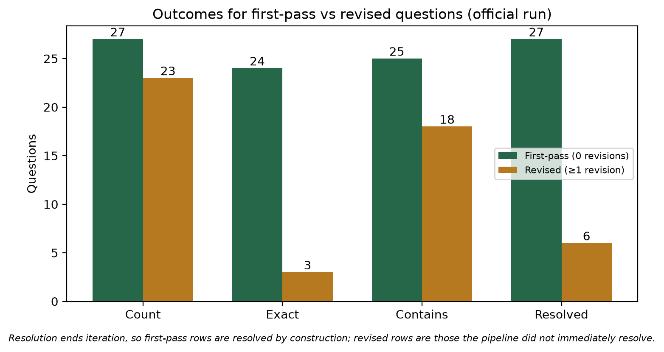
Figure 4. Outcomes for first-pass vs revised questions. Resolution ends iteration, so first-pass rows are resolved by construction.

3.8 Representative trace cases
Full records in research/REPRESENTATIVE_TRACE_CASES.md; summary:
Case | ID (depth) | Outcome | Classification
1 | apollo_hop_001 (1) | exact, RESOLVED, first pass | success baseline
2 | apollo_hop_046 (10) | exact, RESOLVED, 9-edge path, first pass | high-depth success
3 | apollo_hop_036 (8) | exact, RESOLVED after 2 revisions | successful feedback-driven revision (mixed)
4 | apollo_hop_005 (1) | contains, STALLED; degenerate claim Apollo Program — includes → "The Apollo Program." | mixed (extractor instability + literal deterministic handling)
5 | apollo_hop_007 (2) | contains, UNRESOLVED_NO_EVIDENCE despite supported complete path | primarily pipeline (conservative stop logic)
6 | apollo_hop_014 (3) | wrong answer, correctly not resolved (target not satisfied) | primarily model; pipeline behaved as designed
7 | apollo_hop_037 (8) | RESOLVED but final answer "state" (wrong) | primarily pipeline (target/combination semantics)
8 | apollo_hop_050 (10) | contains, unresolved (missing_intermediate_edge) | mixed
9 | nhs_wannacry_h10_q01 (10) | lost initially-correct MS17-010; UNRESOLVED/STALLED | mixed pipeline-mediated model regression
10 | apollo_hop_046 pre-fix vs post-fix | STALLED "Global Ocean" → RESOLVED "Oceanography" | instrument-development pair (pre-fix: pipeline)

4. Discussion
What worked. The instrument ran 50/50 questions with zero transport failures and evaluated every question through Neo4j readback with execution-scoped isolation. Two thirds of questions resolved with graph grounding, 72% produced a complete trusted path, and designed ten-hop chains were traversable end-to-end (Cases 2 and 10 post-fix). The FACT/CLAIM separation held: nothing untrusted was promoted, and every unresolved verdict in the examined cases was honest.
What revision corrected and preserved. Case 3 (apollo_hop_036) is the clearest correction: two feedback-driven revisions converted an unresolved depth-8 answer into an exactly correct, fully path-validated one. In the WannaCry trace, the two SUPPORTED MS17-010 claims persisted across Q2 iterations — supported information was preserved even while the surrounding answer degraded.
Where revision regressed. Only 6 of 23 revised questions resolved, and revised questions ended with far lower exact-match (3/23) than first-pass questions (24/27). The WannaCry Q1 sequence shows the mechanism at trace level: a malformed decomposition ("What was the final fix provided by in...") retargeted the task, the revision replaced a bulletin-bearing answer with "patching", the resulting invented relation (affected_by_final_fix) drew NO_EVIDENCE, and the correct identifier never returned. Revision in this configuration is roughly as able to remove correct information as to add it — an observation, given nondeterminism and sample size, not a rate estimate.
Why textual correctness exceeded pipeline resolution. 86% contains-expected vs 66% resolved is explained by three trace-verified mechanisms: degenerate or over-expanded claim extraction (Cases 4, 9), residual NO_EVIDENCE claims blocking an otherwise supported answer (Case 5), and missing intermediate edges between the start entity and a supported terminal claim (Case 8). These are mostly instrument (pipeline or extractor) phenomena, not wrong answers.
Depth. Descriptively, depth 7–10 questions iterate more, run longer, and resolve less often than depth 1–6 questions, but the pattern is not monotonic (depth 5 was perfect for resolution; depth 3 had the lowest contains-expected) and five questions per depth cannot establish a trend. The strongest supported statement is that designed depth 10 is not a hard barrier: both resolved depth-10 rows produced complete nine-edge trusted paths.
Model vs tool. Applying the first-unsupported-transformation rule: clear model-side failures include wrong or evasive answers with failed recovery (Case 6) and reversed or over-expanded claim extraction (Cases 4, 9, 10 pre-fix trigger). Clear pipeline-side failures include unsafe alignment overwriting a correct terminal claim (Case 10 pre-fix), target validation accepting a generic terminal object (Case 7), conservative stop logic discarding a supported complete path (Case 5), and the unresolved combiner projecting a wrong terminal object (Cases 7 and 10 pre-fix). Mixed failures — malformed LLM decomposition accepted by deterministic validation, over-expanded claims judged literally, accurate feedback followed by regressing revision, thin trusted graphs bridged by unsupported claims — dominate the most instructive cases (8, 9). The WannaCry case is classified as a mixed pipeline-mediated model regression, not as evidence that an 8B model cannot answer a ten-hop question: the same model produced the correct bulletin inside the same execution.
Nondeterminism. Answer wording, decomposition, extracted triples, alignment candidates, and revisions can vary between runs; a repeated execution is a new sample, not a correction. The problematic WannaCry execution was deliberately not rerun; pre-fix and post-fix runs were never pooled.
Contribution. The evidence supports a technical contribution — a working decomposed graph-based backtracking instrument with structured claim-level feedback, strict FACT/CLAIM separation, execution-scoped Neo4j persistence, target and evidence-path validation, full traceability, benchmark tooling, and the reliability safeguards frozen at b9608d0 (Case 10 documents the concrete alignment-drift fix). It also supports a modest research contribution: the textual-correctness vs graph-resolution distinction is measurable and large (86% vs 66%); correction and regression during revision are directly observable at claim level; and graph feedback exposed information loss (Case 9) that final-answer-only evaluation would hide — even in a case where it failed to repair the loss. No claim of broad generalizability is made: one model, one quantitative domain, one run.

5. Conclusion
A frozen build of the GraphEval prototype executed the official 50-question Apollo multihop benchmark cleanly (50/50, zero errors), producing 54% exact-match, 86% contains-expected, and 66% pipeline-resolved outcomes with complete trusted paths in 72% of questions. The gap between textual correctness and graph resolution, the honest refusal to resolve unsupported answers, and trace-visible preservation, correction, and regression during revision are the experiment's principal findings. Ten-hop designed chains were resolvable, and the most informative failure — the WannaCry case — demonstrates precisely the kind of information-loss visibility that motivates graph-grounded evaluation. The evidence base is deliberately bounded: five questions per depth, a single model, a single quantitative domain, and no controlled self-correction baseline.
Immediate future work, kept separate from the completed scope: a controlled comparison of initial answers, generic self-correction, and graph-feedback correction; repeated trials to characterize nondeterminism; additional models and domains; stronger decomposition validation (Case 9's malformed sub-question passed validation); improved trace summarization; and preparation of a publication or poster from this skeleton.

6. References
1. GraphEval prototype repository: grapheval_prototype, branch debug/8b-hop-validation, commit b9608d0f59b5dffd30d2f51aa50cc4be745dcc93 (implementation, benchmark tooling, and all result artifacts cited in this report).
2. [TODO — original GraphEval publication: the repository describes the system as "GraphEval-style" but does not record the source; attribution must be verified before submission.]
3. UK National Audit Office, Investigation: WannaCry cyber attack and the NHS, HC 414, 25 April 2018. (WannaCry benchmark grounding.)
4. Department of Health & Social Care / NHS CIO, Lessons learned review of the WannaCry Ransomware Cyber Attack, 1 February 2018.
5. CISA / US-CERT, Alert TA17-132A: Indicators Associated With WannaCry Ransomware, May 2017.
6. Microsoft, Microsoft Security Bulletin MS17-010 — Critical: Security Update for Microsoft Windows SMB Server, 14 March 2017.
7. Project analysis artifacts: results/research/grapheval_final_experiment_analysis.{json,md}; research/REPRESENTATIVE_TRACE_CASES.md; research/EXPERIMENT_PROTOCOL.md; research/REPRODUCIBILITY_RECORD.md (this repository, 2026-08-02).

